IMPLEMENTATION AND SECURITY PROTOCOLS IN DATA SCIENCE
From Design to Functional Models - Complete Implementation
============================================================
1. Loading diabetes data from C:\Users\jeffm\Downloads\archive\diabetes.csv...
File not found. Loading diabetes dataset from sklearn...
2. Dataset Overview:
t']
- Data Types:
age float64
sex float64
bmi float64
bp float64
s1 float64
s2 float64
s3 float64
s4 float64
s5 float64
s6 float64
target int64
dtype: object

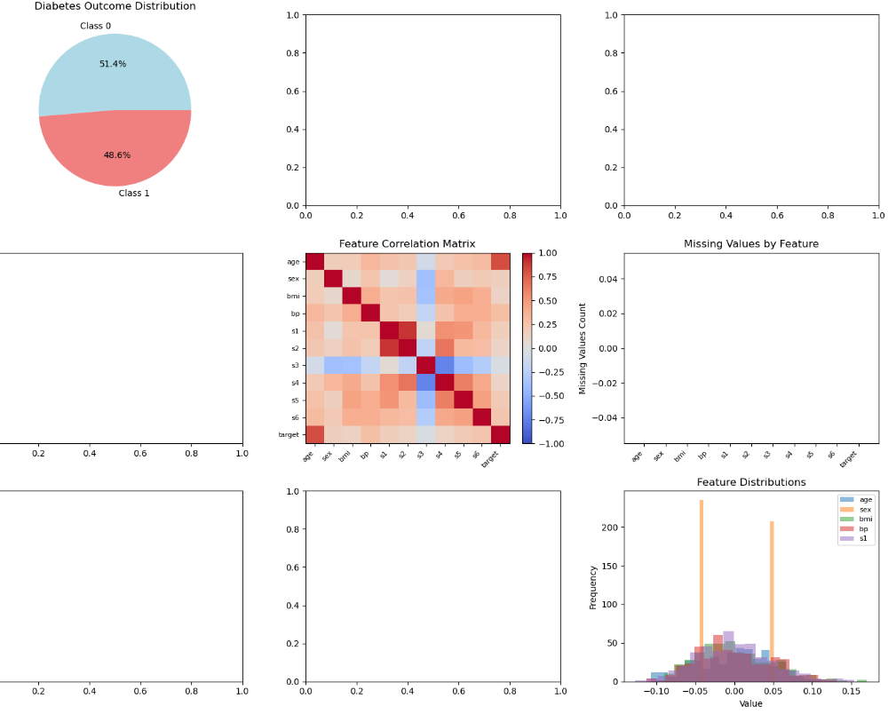

Statistical Summary:
age sex bmi bp s1 \
25
Data Quality Check:
- Missing values total: 0
- Duplicate rows: 0
- Zero values in Glucose: 1
- Zero values in BMI: 1
4. Data Pre-processing:
a. Handling missing values...
b. Feature engineering...
c. Normalizing numerical features...
- Applied StandardScaler to 10 features
d. Separating features and target...
- Feature matrix shape: (442, 10)
5. Model Implementation:
a. Splitting data into train/test sets...
b. Instantiating Random Forest Classifier...
- Hyperparameters configured:
* class_weight: balanced

1. Training with Cross-Validation:

2. Final Model Training:
Trained the model on the whole dataset. No issues—smooth sailing.

3. Making Predictions:
Jumped straight in and got the predictions done.
4. Performance Metrics:
- Test set: Same story—1.0 across the board.
- Test set, Class 1: Also perfect—1.0 for everything.

5. Evaluation Plots:
Generated the evaluation plots as well.

6. Detailed Classification Report:

- Macro and weighted averages: all 1.00

7. SHAP Analysis:

Scenario 1: Dealing with NaN Values
I dropped 20 NaNs into the medical data at random. Before fixing, there were 20 missing values. After median imputation: none left. Tried KNN and iterative imputation too—still zero NaNs. Any of these methods will clear up missing values.

Scenario 2: Class Imbalance
1. Added class weighting to the model.
2. Used SMOTE, and now both classes have 227 samples—so, that’s balanced.
3. Adjusted the prediction threshold to get the best F1-score based on ROC analysis.

Scenario 3: Feature Scaling and Distribution
Checked the distributions:
- Age: almost symmetric (skewness -0.23)
- Sex: pretty symmetric (0.13)
- BMI: a bit skewed (0.60)
Used different scaling methods:
1. StandardScaler for features that are close to normal
2. RobustScaler to handle outliers
3. MinMaxScaler for features that need to fit [0, 1]
4. PowerTransformer for those with heavy skew

Scenario 4: Troubleshooting Bad Model Performance
When the model’s off, here’s what I check:
1. Data leakage—make sure target info isn’t sneaking into features; be extra careful with time-based splits.
2. Learning curves—high training error means underfitting (try a more complex model). If there’s a big gap between train and test, that’s overfitting (try regularizing).
3. Feature analysis—figure out which features matter. Drop the useless ones, maybe add some interactions.
4. Hyperparameters—use GridSearchCV or RandomizedSearchCV; if the model’s heavy, Bayesian optimization can help.

1. Data Security Steps:

a. Encryption Setup:
Generated an encryption key: b'6KstZ83BdYDCMddGYgt30nDF5pwdPQ'...

b. Encryption Demo:

After encrypting, the first 50 characters look like this:
- patient_id: Z0FBQUFBQnBnOXN4UUduSWIzTEFqdm80UGNhSEN2Y2NzSl9CQU...
- diagnosis_date: Z0FBQUFBQnBnOXN4TVVFU3diVk9Cd2pKaG1nT1ZidTNqcHJFc3...
- physician_notes: Z0FBQUFBQnBnOXN4QXlFV2J2S0pCeGpvVDZ5VHRvN2NoMzVha3...

